

**KARNATAK UNIVERSITY**

**Shivaji Education Society’s**

SHIVAJI ARTS, COMMERCE & BCA COLLEGE, BAAD, KARWAR

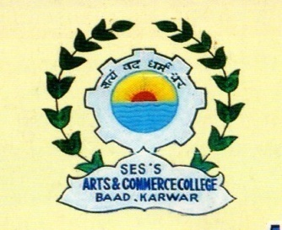

**Department Of Computer Application**

**PROJECT REPORT ON**

**“PICTZA”**

**SUBMITTED BY**

**Mr. RAHUL G. NAIK**

**REG. NO. 20U12216**

**IN PARTIAL FULFILLMENT OF REQUIREMENT FOR AWARD OF DEGREE**

**“BACHELOR OF COMPUTER APPLICATION”**

|  |
| --- |
| **INTERNAL GUIDE**  **MISS. NAUSHEEN MULLA** |



**KARNATAK UNIVERSITY**

**Shivaji Education Society’s**

**SHIVAJI ARTS, COMMERCE &BCA COLLEGE**

**BAAD, KARWAR**

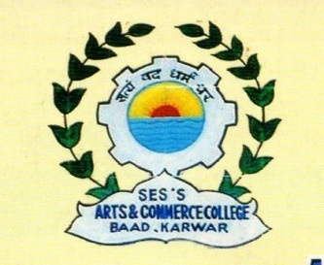

**Department Of Computer Application**

**PROJECT REPORT ON**

**“PICTZA”**

**CERTIFICATE**

This is to certify that Mr. **RAHUL G. NAIK** is the student of our college studying in V1 semester of BCA course bearing register number **20U12216**.

He was permitted to undertake a project work at **“, Karwar”,** entitled **“PICTZA”** from **Apr 2023 to Aug 2023**.

This project is based on the studies carried out in the Department and the project work or part of it has not been submitted for any other degree, diploma, associateship, fellowship or other similar title.

|  |  |  |
| --- | --- | --- |
| **Miss.Nausheen Mulla**  **Internal Guide** | **Miss. Pratyaksha Siddarkar**  **Head of the Department** | **Dr. Anuradha Naik**  **Principal** |

**Examiners:**

1.